Project Development Phase
Performance Test

Date | 03 October 2026
Team ID | SWTID-2026-8647
Project Name | Implement Client Script & UI Policy (Incident)
Maximum Marks

ServiceNow Project Performance Testing:
Project team shall fill the following information for the ServiceNow Incident configuration project.
S.No. | Parameter | Screenshot / Values
1. | UI Policy Action – Assignment Group | 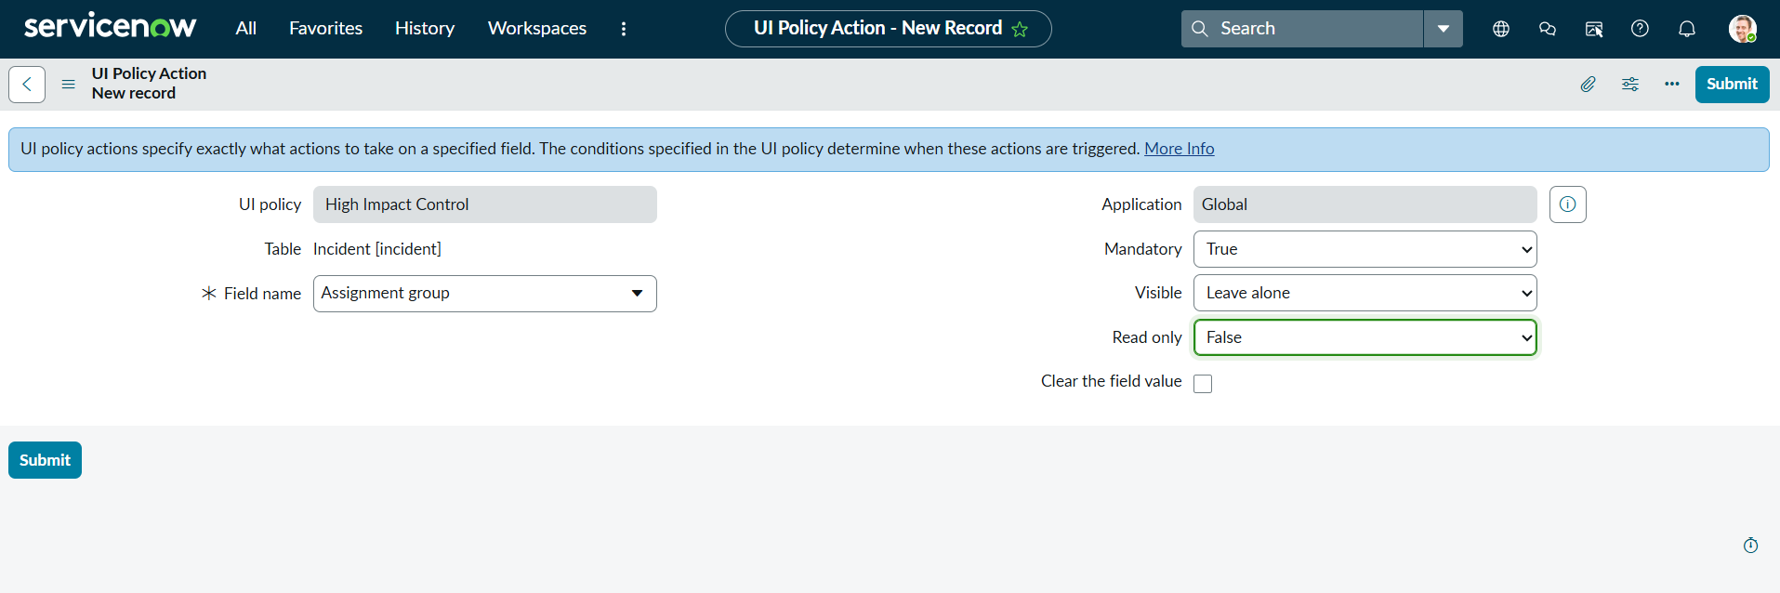  Configuration evidence: Assignment group is set as Mandatory = True. Execution result: To be verified during implementation.
2. | UI Policy Action – Urgency | 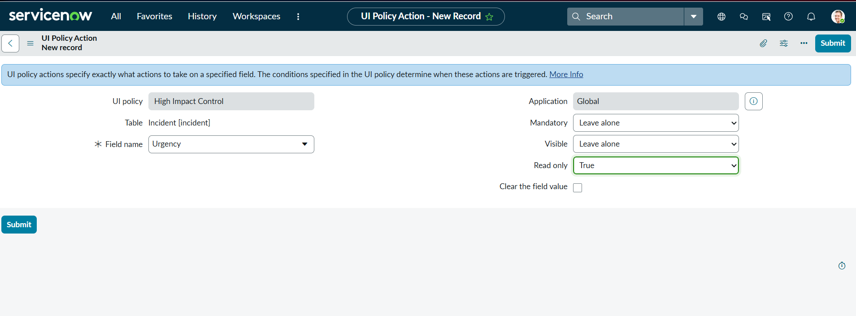  Configuration evidence: Urgency is configured as Read only = True. Execution result: To be verified during implementation.
3. | Client Script – Auto Set Urgency | 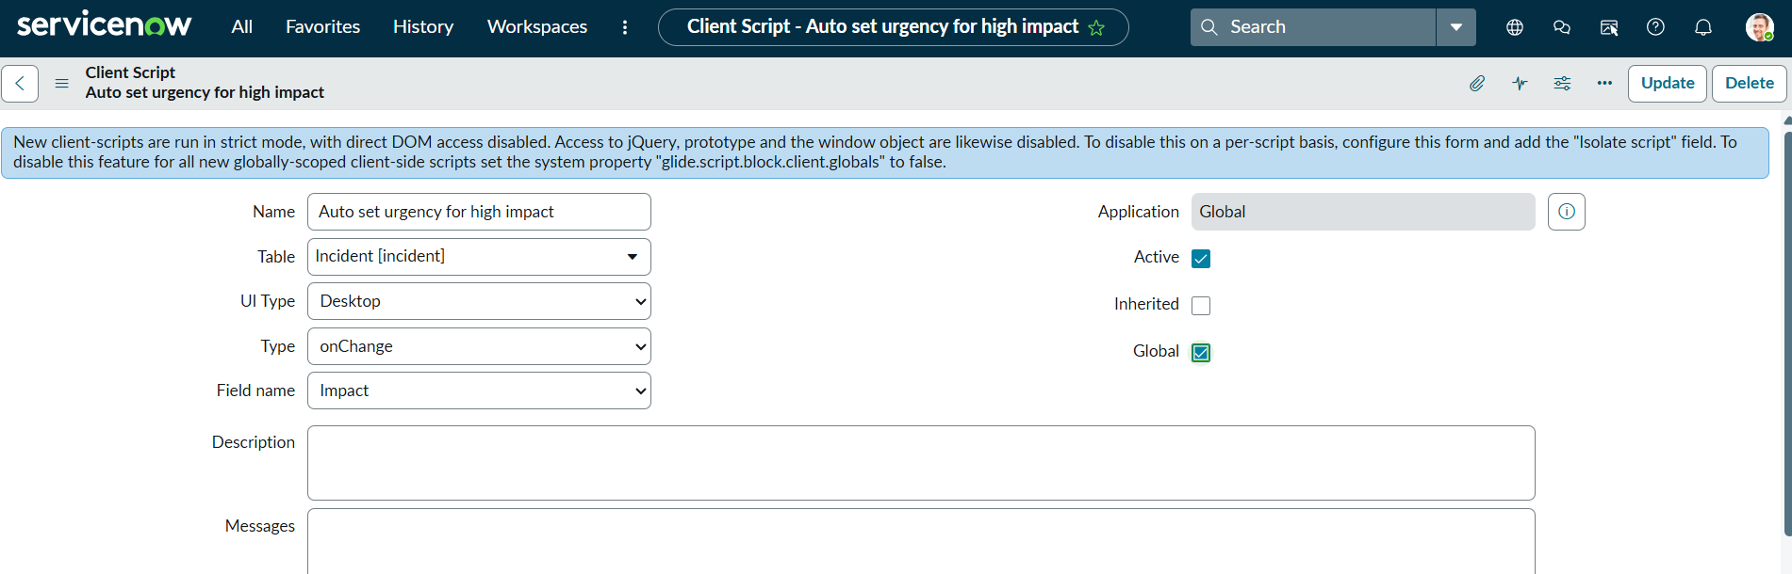  Configuration evidence: Client Script is configured on the Incident table as an onChange script for the Impact field. Execution result: To be verified during implementation.
4. | Client Script – Prevent Save if Assigned To Missing | 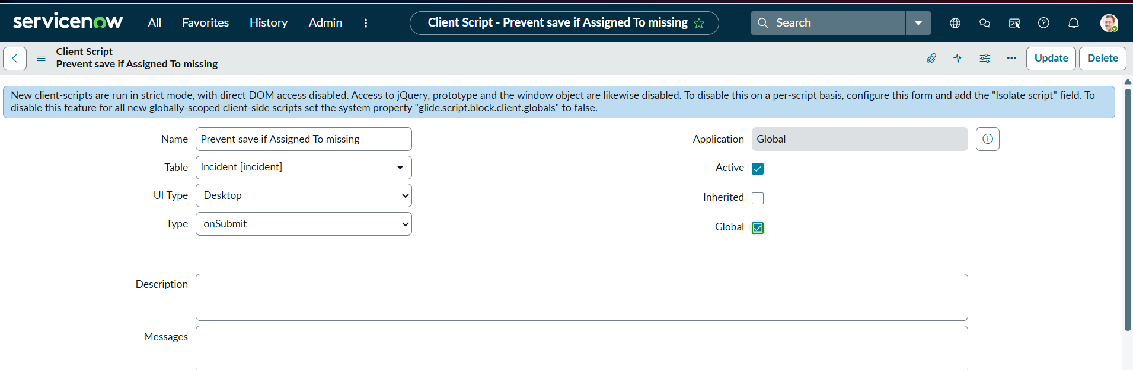  Configuration evidence: Client Script is configured on the Incident table as an onSubmit validation control. Execution result: To be verified during implementation.
5. | Client Script – Prevent State Change via List Edit | 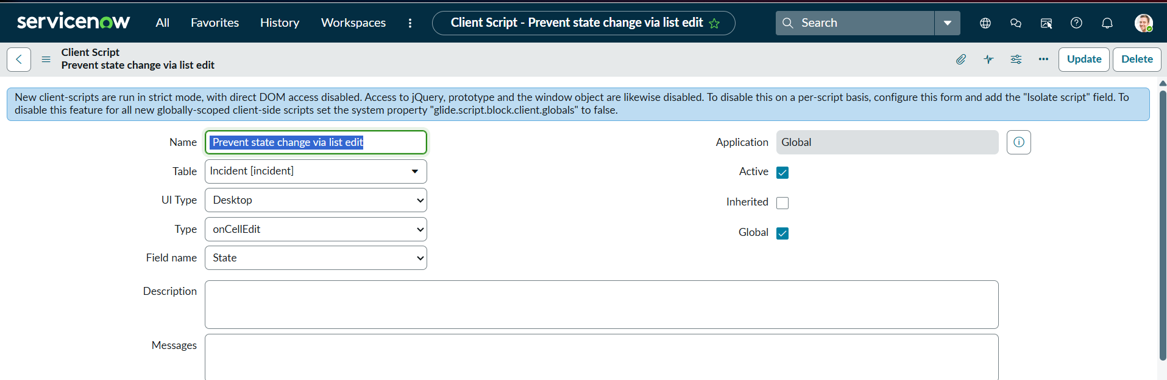  Configuration evidence: Client Script is configured on the Incident table as an onCellEdit control for State. Execution result: To be verified during implementation.
6 | Configuration / Validation Evidence | Overall project evidence is based on the supplied ServiceNow configuration screenshots. Final functional validation: To be verified during implementation.

